Advanced Web Apps

# Module 04

This is the project wireframe website I have created. Some things that were worked on regarding the site:

* Multiple labels and coded new colors and text
* A multiple jumbotrons
* Multiple new cards with associated links and buttons updated colors and text!

Rasmussen College - Professor Corey



This module project saw more updated to the index page and the addition of the about page which has been linked throughout the site. This will allow the user to begin navigating through the site. I have changed background colors, added multiple sets of cards, added buttons, changed the jumbotron, and resized the necessary images so they fit within the context of the site.

The URL for my page is located here and also posted at my GitHub account:

[https://](https://sotd.us/jasonkendall/module04/bootstrap-4.2.1-dist/index.html)sotd.us/jasonkendall/module04/project/index.html

https://github.com/jasonhkendall/AdvancedWebApps/tree/master/module04/projectImages of the development process are located here:

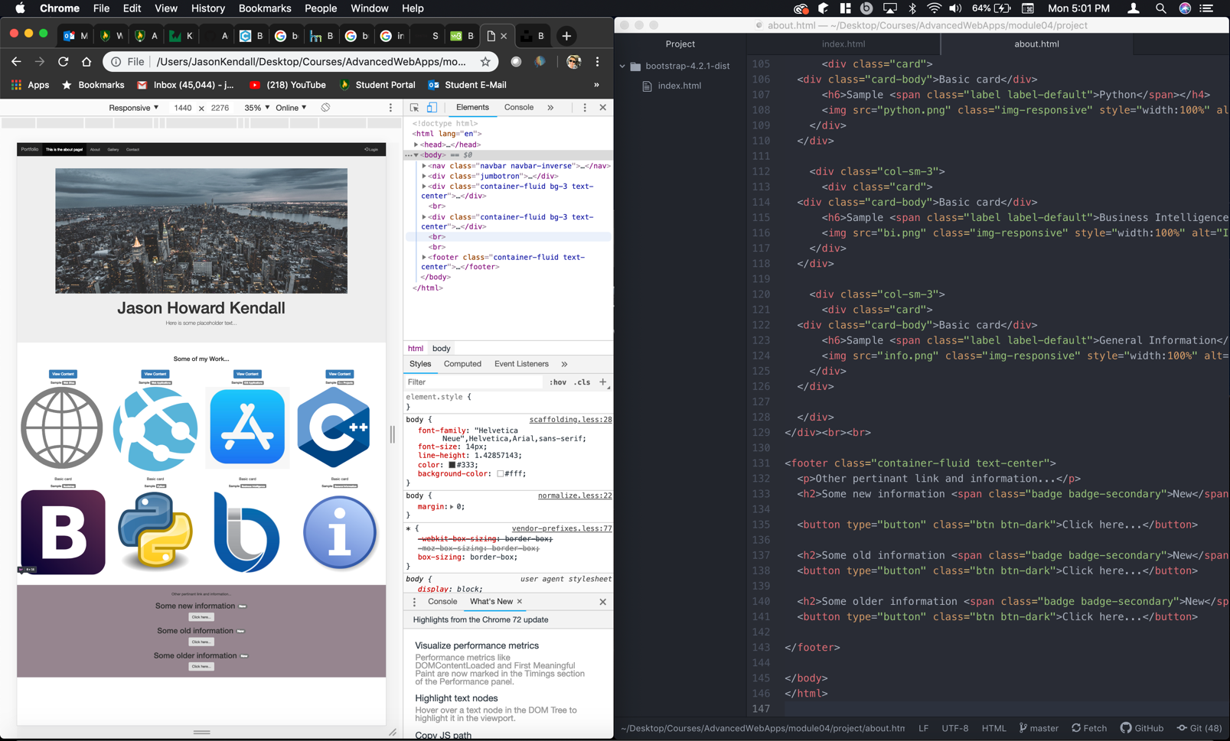

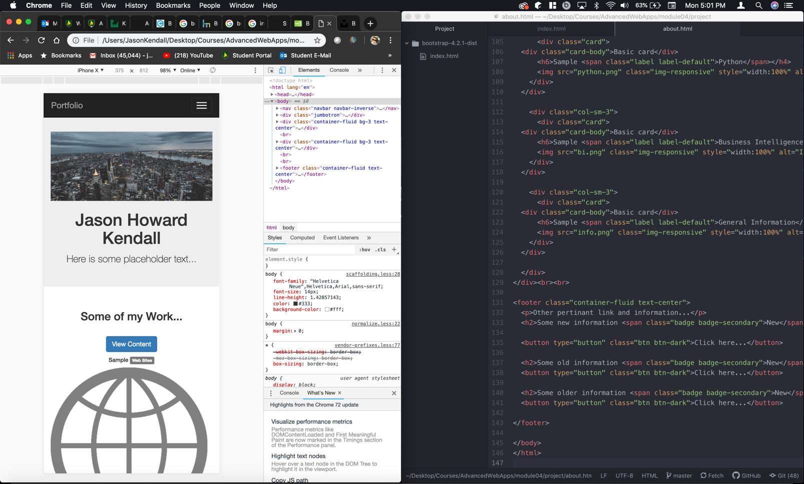

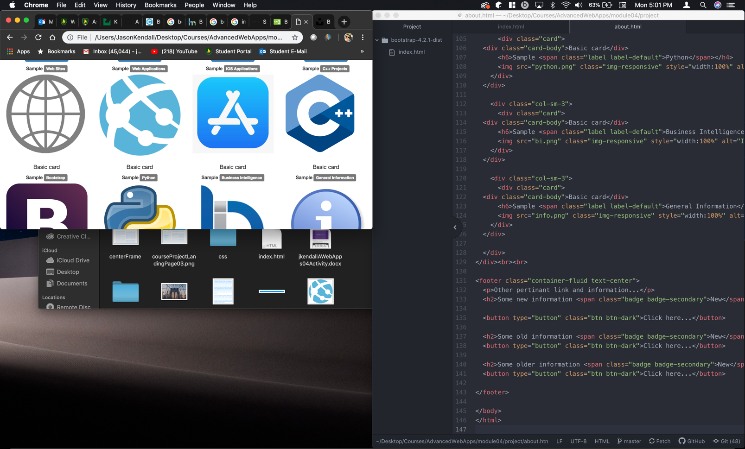

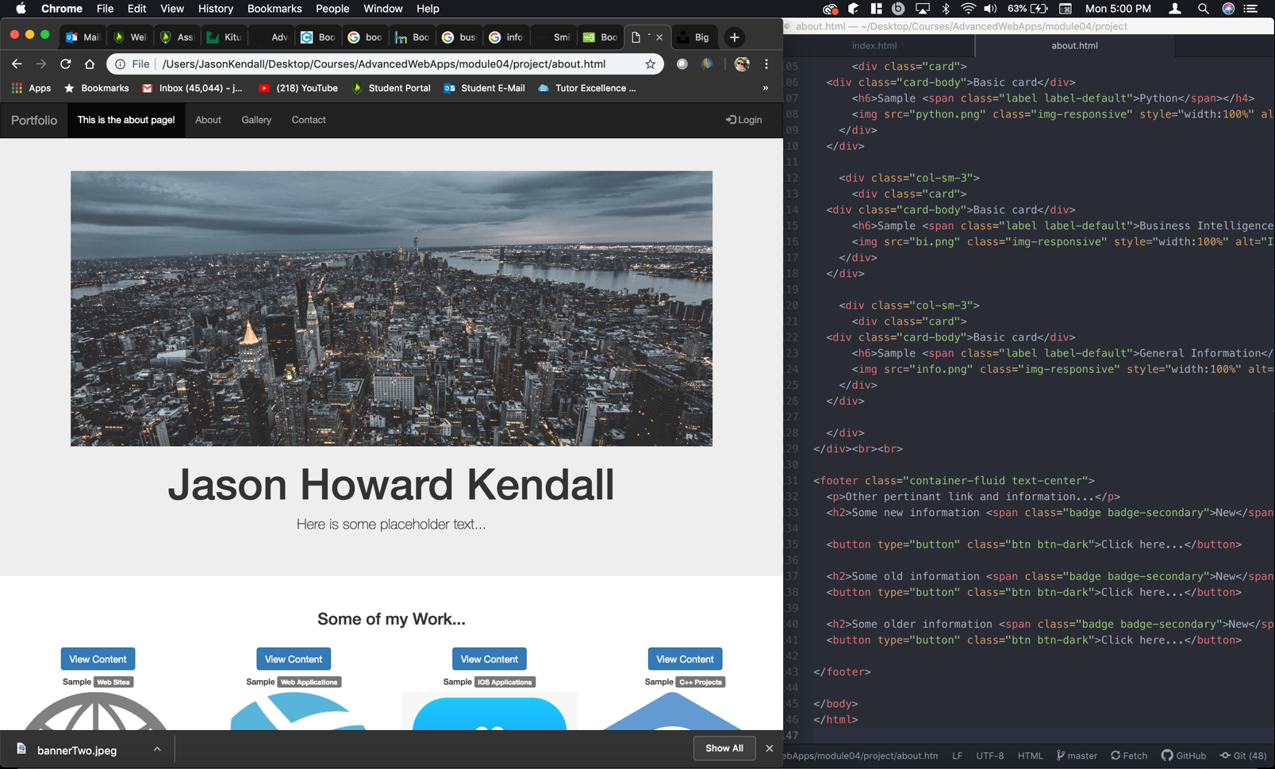

Thanks!